Testing in the Context of a Software Development Lifecycle

What is Testing in the Context of a Software Development Lifecycle (SDLC)
# Source: AI Source: Provided by: [Data Path: Persons Table -> ID Column: 1, Name_En Column: Motasem Essam] -> From: [ChatGPT] on [8/21/2025]
Testing in the Context of a Software Development Lifecycle (SDLC)
means integrating testing activities throughout the different phases of software development — not just at the end.
In modern approaches (like Agile or DevOps), testing is a continuous process that starts early (Shift-Left Testing) and continues after release (Shift-Right Testing).

How Testing Fits into Each SDLC Phase
# Source: AI Source: Provided by: [Data Path: Persons Table -> ID Column: 1, Name_En Column: Motasem Essam] -> From: [ChatGPT] on [8/21/2025]
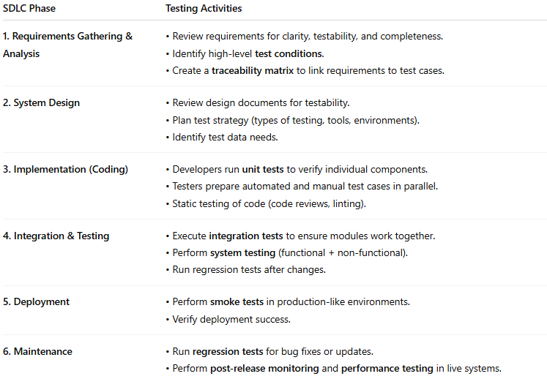
SDLC Phase | Testing Activities
1. Requirements Gathering & Analysis | • Review requirements for clarity, testability, and completeness.• Identify high-level test conditions.• Create a traceability matrix to link requirements to test cases.
2. System Design | • Review design documents for testability.• Plan test strategy (types of testing, tools, environments).• Identify test data needs.
3. Implementation (Coding) | • Developers run unit tests to verify individual components.• Testers prepare automated and manual test cases in parallel.• Static testing of code (code reviews, linting).
4. Integration & Testing | • Execute integration tests to ensure modules work together.• Perform system testing (functional + non-functional).• Run regression tests after changes.
5. Deployment | • Perform smoke tests in production-like environments.• Verify deployment success.
6. Maintenance | • Run regression tests for bug fixes or updates.• Perform post-release monitoring and performance testing in live systems.

Key Principles
# Source: AI Source: Provided by: [Data Path: Persons Table -> ID Column: 1, Name_En Column: Motasem Essam] -> From: [ChatGPT] on [8/21/2025]
- Shift Left: Start testing as early as possible in the SDLC to find defects sooner (cheaper to fix).
- Continuous Testing: Automated tests run frequently in CI/CD pipelines.
- Test Basis Connection: All tests trace back to requirements or design docs.
- Feedback Loops: Testing provides quick feedback to developers to improve quality.

Visual Overview
# Source: AI Source: Provided by: [Data Path: Persons Table -> ID Column: 1, Name_En Column: Motasem Essam] -> From: [ChatGPT] on [8/21/2025]
Here’s a simple flow of SDLC with Testing:
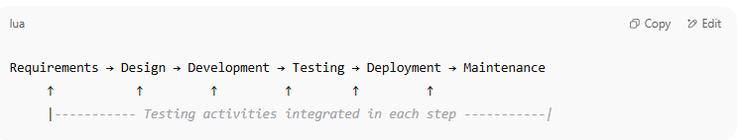
Requirements → Design → Development → Testing → Deployment → Maintenance
↑ ↑ ↑ ↑ ↑ ↑
|----------- Testing activities integrated in each step -----------|

Testing in Each SDLC Model
# Source: AI Source: Provided by: [Data Path: Persons Table -> ID Column: 1, Name_En Column: Motasem Essam] -> From: [ChatGPT] on [8/21/2025]
Alright — let’s break down Testing in Each SDLC Model so you can see how it’s handled depending on the development approach.

1. Waterfall Model
# Source: AI Source: Provided by: [Data Path: Persons Table -> ID Column: 1, Name_En Column: Motasem Essam] -> From: [ChatGPT] on [8/21/2025]
- Testing Phase: Happens after development is complete.
- Characteristics:
  - Sequential; no overlap between phases.
  - Testing only starts when coding ends.
- Pros: Clear structure, easy to manage for small projects.
- Cons: Defects are found late; costly to fix.
- Example: Traditional government or manufacturing software projects.

2. V-Model (Verification & Validation Model)
# Source: AI Source: Provided by: [Data Path: Persons Table -> ID Column: 1, Name_En Column: Motasem Essam] -> From: [ChatGPT] on [8/21/2025]
- Testing Phase: Testing activities are planned parallel to each development phase.
- Characteristics:
  - Left side = development stages (requirements → design → coding).
  - Right side = corresponding testing stages (unit → integration → system → acceptance testing).
- Pros: Testing starts early, better defect prevention.
- Cons: Less flexible for changing requirements.
- Example: Safety-critical software (medical devices, aerospace).

3. Iterative & Incremental Model
# Source: AI Source: Provided by: [Data Path: Persons Table -> ID Column: 1, Name_En Column: Motasem Essam] -> From: [ChatGPT] on [8/21/2025]
- Testing Phase: Each iteration delivers part of the system and includes its own testing cycle.
- Characteristics:
  - Testing happens at the end of each iteration.
  - Continuous feedback to refine requirements.
- Pros: Early delivery of working parts, early defect detection.
- Cons: Requires strong planning for integration.
- Example: Banking systems, large enterprise apps.

4. Agile Model
# Source: AI Source: Provided by: [Data Path: Persons Table -> ID Column: 1, Name_En Column: Motasem Essam] -> From: [ChatGPT] on [8/21/2025]
- Testing Phase: Testing is continuous within short sprints.
- Characteristics:
  - Testers work closely with developers.
  - Test automation is heavily used.
  - Frequent regression testing.
- Pros: Fast feedback, adaptable to changes.
- Cons: Requires high collaboration and skilled team members.
- Example: Web apps, startups, SaaS products.

5. Spiral Model
# Source: AI Source: Provided by: [Data Path: Persons Table -> ID Column: 1, Name_En Column: Motasem Essam] -> From: [ChatGPT] on [8/21/2025]
- Testing Phase: Testing occurs in each cycle (prototype → build → refine).
- Characteristics:
  - Combines iterative development with risk analysis.
  - Early prototypes tested before full implementation.
- Pros: Great for managing high-risk projects.
- Cons: Can be costly and complex.
- Example: R&D software, defense projects.

6. Big Bang Model
# Source: AI Source: Provided by: [Data Path: Persons Table -> ID Column: 1, Name_En Column: Motasem Essam] -> From: [ChatGPT] on [8/21/2025]
- Testing Phase: Testing happens after coding everything — no intermediate testing.
- Characteristics:
  - No formal process, just build and test at the end.
- Pros: Simple for very small projects.
- Cons: Extremely risky, late defect discovery.
- Example: Proof-of-concept projects.

SDLC and good testing practices
# Source: AI Source: Provided by: [Data Path: Persons Table -> ID Column: 1, Name_En Column: Motasem Essam] -> From: [ChatGPT] on [8/21/2025]
Here’s a clear overview of SDLC combined with good testing practices so you can see how they fit together.

1. SDLC Phases with Testing Focus
# Source: AI Source: Provided by: [Data Path: Persons Table -> ID Column: 1, Name_En Column: Motasem Essam] -> From: [ChatGPT] on [8/21/2025]
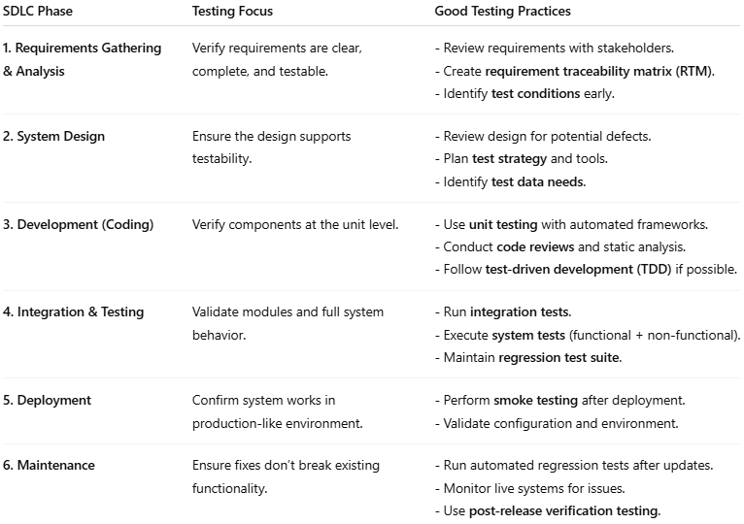
SDLC Phase | Testing Focus | Good Testing Practices
1. Requirements Gathering & Analysis | Verify requirements are clear, complete, and testable. | - Review requirements with stakeholders.- Create requirement traceability matrix (RTM).- Identify test conditions early.
2. System Design | Ensure the design supports testability. | - Review design for potential defects.- Plan test strategy and tools.- Identify test data needs.
3. Development (Coding) | Verify components at the unit level. | - Use unit testing with automated frameworks.- Conduct code reviews and static analysis.- Follow test-driven development (TDD) if possible.
4. Integration & Testing | Validate modules and full system behavior. | - Run integration tests.- Execute system tests (functional + non-functional).- Maintain regression test suite.
5. Deployment | Confirm system works in production-like environment. | - Perform smoke testing after deployment.- Validate configuration and environment.
6. Maintenance | Ensure fixes don’t break existing functionality. | - Run automated regression tests after updates.- Monitor live systems for issues.- Use post-release verification testing.

2. Good Testing Practices Across the SDLC
# Source: AI Source: Provided by: [Data Path: Persons Table -> ID Column: 1, Name_En Column: Motasem Essam] -> From: [ChatGPT] on [8/21/2025]
These apply no matter the model (Waterfall, Agile, V-Model, etc.):
- Shift-Left Testing
  - Start testing activities early in the SDLC to catch defects sooner.
- Traceability
  - Link every test case to a requirement (RTM) so nothing is missed.
- Test Automation Where Suitable
  - Automate repetitive, stable test cases (unit, regression, smoke tests).
- Continuous Testing in CI/CD
  - Integrate automated tests into the build pipeline.
- Test Data Management
  - Use realistic, valid, and anonymized test data.
- Regular Regression Testing
  - Ensure changes don’t break previously working features.
- Balanced Testing Levels
  - Use a Test Pyramid approach: more unit tests, fewer UI tests.
- Static Testing
  - Review and inspect requirements, designs, and code before execution testing.
- Risk-Based Testing
  - Prioritize testing of high-impact, high-probability failure areas.
- Clear Test Documentation
  - Maintain up-to-date test plans, cases, and reports.

